Dried Berries Market – Global Industry Analysis, Size, Share, Growth, Trends and Forecast, 2026 – 2036
An introduction to TMR  Transparency Market Research (TMR) is a premier provider of syndicated research reports, custom research reports, and consulting services. We deliver a complete packaged solution, which combines current market intelligence, statistical anecdotes, technology inputs, valuable growth insights, aerial view of the competitive framework, and future market trends.  Published Reports  2,500+  Domain Covered  25  Clients Engaged  350+  Analysts Team  400+   |  |  | Taxonomy Defined  By Berry Type  By Drying Process  By Product Form  By Nature  By Application  By Sales Channel  By Region  Report delivery Distribution format; PPT converted to PDF
Research Capabilities  - Pharmaceuticals  - Medical Devices  - Chemicals & Materials  - Technology & Media  - Energy & Mining  - Food & Beverages  - Semiconductor & Electronics  - Consumer Goods  - Biotechnology  - Healthcare IT  - Metals & Minerals  - Defense & Aeronautics  - Packaging | Sector Coverage  - Syndicate Research  - Custom Research  - Consulting Services

 |  | By Berry Type |  |  | By Drying Process |  |  |  | By Product Form
- Strawberries  - Raspberries  - Boysenberries  - Blueberries  - Blackberries  - Cranberries  - Other Berries |  |  |  | - Sun-Dried  - Hot-Air Dried  - Freeze-Dried  - Vacuum-Dried  - Other Drying Processes |  |  | - Whole Dried Berries  - Sliced Dried Berries  - Dried Berry Pieces  - Dried Berry Powders  - Flakes and Crisps
 |  | By Nature |  |  | By Application |  |  | By Sales Channel
- Conventional  - Certified Organic |  |  |  | - Bakery and Confectionery  - Breakfast Cereals and Snack Bars  - Dairy Products and Frozen Desserts  - Snacks and Trail Mixes  - Beverages and Beverage Preparations  - Jams, Sauces and Fruit Preparations  - Foodservice and Catering  - Other Applications |  |  | - Supermarkets and Hypermarkets  - Convenience Stores  - Traditional Grocery Stores  - Discount Retailers  - Specialty Food Retailers  - E-commerce Platforms and Online Grocery  - Direct-to-Consumer Brand Websites  - Other Sales Channels
 | By Packaging Type |  |  |  | By Region
- Flexible Pouches and Bags  - Rigid Containers  - Cartons and Boxes  - Bulk Industrial Packaging |  |  |  | - North America  - Latin America  - Western Europe  - Eastern Europe  - East Asia  - South Asia and Pacific  - Middle East and Africa

Sample Graphs & Representation    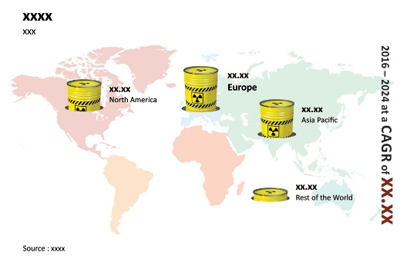  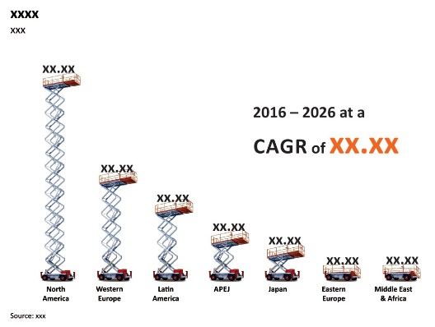  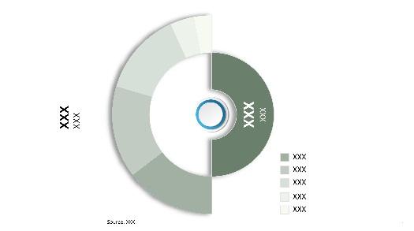  Images are only for illustration purpose  Sample Graphs & Representation  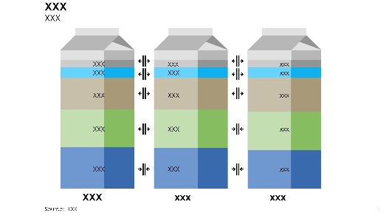  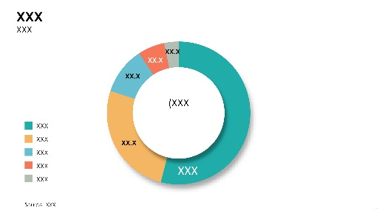    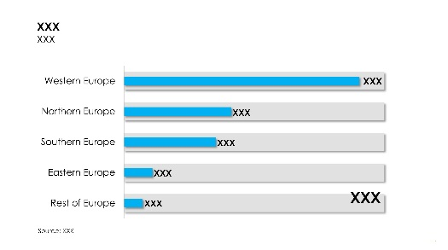  Images are only for illustration purpose  Sample Graphs & Representation  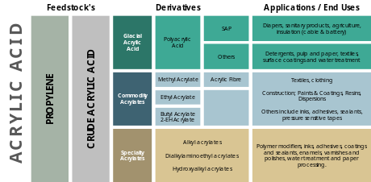  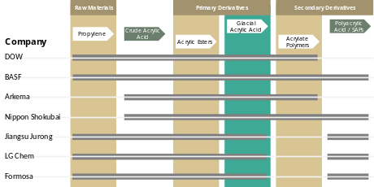  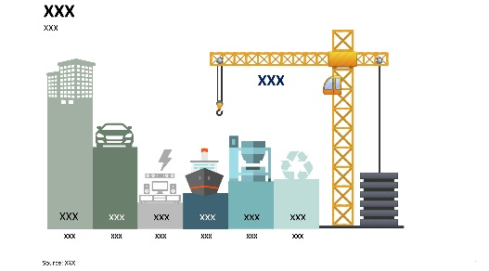    Images are only for illustration purpose  Sample Graphs & Representation  Images are only for illustration purpose  Sample Graphs & Representation  Images are only for illustration purpose  Sample Graphs & Representation  Sample Graphs & Representation  Images are only for illustration purpose  Sample Graphs & Representation  Images are only for illustration purpose  Sample Graphs & Representation  Images are only for illustration purpose  Sample Graphs & Representation  Images are only for illustration purpose  Sample Graphs & Representation  Images are only for illustration purpose  Sample Graphs & Representation  Sample Graphs & Representation  Images are only for illustration purpose  Sample Graphs & Representation  Images are only for illustration purpose |  | - Executive Summary  - Global Market Outlook  - Demand Side Trends  - Supply Side Trends  - Technology Roadmap  - Analysis and Recommendations  - Market Overview  - Market Coverage / Taxonomy  - Market Definition / Scope / Limitations  - Key Market Trends  - Key Trends Impacting the Market  - Product Innovation / Development Trends  - Key Success Factors  - Product Adoption / Consumption Analysis  - Product Differentiation / Taste, Texture & Flavor Features  - Manufacturing Technology & Production Efficiency  - Food Safety Compliance & Ingredient Quality  - Product Variety, Customization & Packaging Flexibility  - Global Dried Berries Market Demand Analysis 2021–2025 and Forecast, 2026–2036  - Historical Market Volume (Units) Analysis, 2021–2025  - Current and Future Market Volume (Units) Projections, 2026–2036  - Y-o-Y Growth Trend Analysis  - Global Dried Berries Market - Pricing Analysis  - Regional Price Assessment  - Manufacturer Level Pricing  - Distributor Level Pricing  - Retail Level Pricing  - Segment-wise Price Comparison (Berry Type vs Drying Process)  - Country-wise Price Comparison (Berry Type)  - Price Forecast till 2036  - Factors Impacting Pricing  - Competitor Pricing Strategies  - Pricing and Premiumization Analysis  - Retail price trends by country and product format, 2021–2036  - Revenue and volume share by price tier  - Branded versus private-label price premiums  - Price elasticity and promotional sales impact by country  - Revenue opportunity from premiumization and affordable indulgence  - Global Dried Berries Market Demand (US$ Mn) Analysis 2021–2025 and Forecast, 2026–2036  - Historical Market Value (US$ Mn) Analysis, 2021–2025  - Current and Future Market Value (US$ Mn) Projections, 2026–2036  - Y-o-Y Growth Trend Analysis  - Absolute $ Opportunity Analysis  - Market Background  - Regional Macro-& Micro Economic Indicators  - Macro Economic Indicators  - Global Berry Production and Harvest Yield Trends  - International Trade Flows of Dried Berries  - Global Food Processing Industry Growth  - Global Energy Price Trends  - International Freight and Cold-Chain Logistics Costs  - Micro Economic Indicators  - Fresh Berry Procurement Prices  - Dried Berry Processing and Conversion Costs  - Freeze-Drying and Dehydration Capacity Utilization  - Dried Berry Wholesale Price Trends  - Food Manufacturer Demand for Dried Berry Ingredients  - Forecast Factors - Relevance & Impact  - Dried Berries Consumption for Capita  - Fresh Berry Production and Harvest Yield Trends  - Raw Berry Procurement Prices and Availability  - Energy Costs for Drying and Dehydration Processes  - Dried Berries Retail Sales Volume  - Demand for Dried Berry Ingredients in Bakery, Confectionery, and Snack Manufacturing  - Consumer Spending on Healthy Snacks and Fruit-Based Products  - International Trade Flows and Import Dependence for Dried Berries  - Seasonal Berry Harvests and Holiday-Related Consumption Patterns  - Dried Berry Product Launches, Processing Innovations, and New Product Formulations  - Value Chain  - Customer and Voice-of-Customer Assessment  - Customer Profile and Dried Berry Purchasing Patterns  - Procurement Volumes and Purchase Frequency by Customer Type  - Key Supplier Selection and Purchasing Criteria  - Price Sensitivity and Willingness to Pay for Premium Dried Berries  - Supplier Switching Behaviour and Long-Term Sourcing Preferences  - Unmet Customer Needs and Expectations from Dried Berry Suppliers  - Market Dynamics  - Drivers  - Restraints  - Opportunity Analysis  - Regulations  - PESTEL Analysis  - Porter’s Analysis  - Dried Berry Product Innovation and Application Development Assessment  - New Product Launches and Commercial Innovation Trends  - Demand for Different Dried Berry Formats Across Food Applications  - Clean-Label, No-Added-Sugar and Organic Product Development  - Application-Specific Requirements for Texture, Colour, Flavour and Moisture  - Dried Berry Ingredient Blends and Multi-Berry Formulations  - Product Development Opportunities in Emerging Food Applications  - Manufacturing Economics and Profitability  - Manufacturing cost structure by cocoa, milk solids, sugar and packaging  - Production cost per kilogram by product format and scale  - Gross margin and EBITDA margin benchmarks, where disclosed  - Cocoa cost inflation versus selling price changes and margin impact  - Contract manufacturing versus in-house production economics  - Global Dried Berries Market Outlook, 2021–2036, by Berry Type  - Introduction / Key Findings  - Historical Market Size (US$ Mn) and Volume Analysis By Berry Type, 2021–2025  - Market Size (US$ Mn) and Volume Analysis and Forecast By Berry Type, 2026–2036  - Strawberries  - Raspberries  - Boysenberries  - Blueberries  - Blackberries  - Cranberries  - Other Berries  - Market Attractiveness Analysis By Berry Type  - Global Dried Berries Market Outlook, 2021–2036, by Drying Process  - Introduction / Key Findings  - Historical Market Size (US$ Mn) and Volume Analysis By Drying Process, 2021–2025  - Market Size (US$ Mn) and Volume Analysis and Forecast By Drying Process, 2026–2036  - Sun-Dried  - Hot-Air Dried  - Freeze-Dried  - Vacuum-Dried  - Other Drying Processes  - Market Attractiveness Analysis By Drying Process  - Global Dried Berries Market Outlook, 2021–2036, by Product Form  - Introduction / Key Findings  - Historical Market Size (US$ Mn) and Volume Analysis By Product Form, 2021–2025  - Market Size (US$ Mn) and Volume Analysis and Forecast By Product Form, 2026–2036  - Whole Dried Berries  - Sliced Dried Berries  - Dried Berry Pieces  - Dried Berry Powders  - Dried Berry Crisps  - Market Attractiveness Analysis By Product Form  - Global Dried Berries Market Outlook, 2021–2036, by Nature  - Introduction / Key Findings  - Historical Market Size (US$ Mn) and Volume Analysis By Nature, 2021–2025  - Market Size (US$ Mn) and Volume Analysis and Forecast By Nature, 2026–2036  - Conventional  - Certified Organic  - Market Attractiveness Analysis By Nature  - Global Dried Berries Market Outlook, 2021–2036, by Application  - Introduction / Key Findings  - Historical Market Size (US$ Mn) and Volume Analysis By Application, 2021–2025  - Market Size (US$ Mn) and Volume Analysis and Forecast By Application, 2026–2036  - Bakery and Confectionery  - Breakfast Cereals and Snack Bars  - Dairy Products and Frozen Desserts  - Snacks and Trail Mixes  - Beverages and Beverage Preparations  - Jams, Sauces and Fruit Preparations  - Other Food Processing Applications  - Market Attractiveness Analysis By Application  - Global Dried Berries Market Outlook, 2021–2036, By Sales Channel  - Introduction / Key Findings  - Historical Market Size (US$ Mn) and Volume Analysis By Application, 2021–2025  - Market Size (US$ Mn) and Volume Analysis and Forecast By Application, 2026–2036  - Supermarkets and Hypermarkets  - Convenience Stores  - Traditional Grocery Stores  - Discount Retailers  - Specialty Food Retailers  - E-commerce Platforms and Online Grocery  - Direct-to-Consumer Brand Websites  - Other Sales Channels  - Market Attractiveness Analysis By Sales Channel  - Global Dried Berries Market Outlook, 2021–2036, by Packaging Type  - Introduction  - Historical Market Size (US$ Mn) and Volume Analysis By Packaging Type, 2021–2025  - Market Size (US$ Mn) and Volume Analysis and Forecast By Packaging Type, 2026–2036  - Flexible Pouches and Bags  - Rigid Containers  - Cartons and Boxes  - Bulk Industrial Packaging  - Global Dried Berries Market Outlook, 2021–2036, by Region  - Introduction  - Historical Market Size (US$ Mn) and Volume Analysis By Region, 2021–2025  - Market Size (US$ Mn) and Volume Analysis and Forecast By Region, 2026–2036  - North America  - Latin America  - Western Europe  - Eastern Europe  - Middle East and Africa (MEA)  - East Asia  - South Asia and Pacific  - Market Attractiveness Analysis By Region  - North America Dried Berries Market Outlook, 2021–2036  - Introduction  - Pricing Analysis  - Historical Market Size (US$ Mn) and Volume Trend Analysis By Market Taxonomy, 2021–2025  - Market Size (US$ Mn) and Volume Forecast By Market Taxonomy, 2026–2036  - By Country  - U.S.  - Canada  - Mexico  - By Berry Type  - By Drying Process  - By Product Form  - By Nature  - By Application  - By Sales Channel  - By Packaging Type  - Market Attractiveness Analysis  - By Country  - By Berry Type  - By Drying Process  - By Product Form  - By Nature  - By Application  - By Sales Channel  - By Packaging Type  - Market Trends  - Key Market Participants - Intensity Mapping  - Drivers and Restraints - Impact Analysis  - Latin America Dried Berries Market Outlook, 2021–2036  - Introduction  - Pricing Analysis  - Historical Market Size (US$ Mn) and Volume Trend Analysis By Market Taxonomy, 2021–2025  - Market Size (US$ Mn) and Volume Forecast By Market Taxonomy, 2026–2036  - By Country  - Brazil  - Argentina  - Rest of Latin America  - By Berry Type  - By Drying Process  - By Product Form  - By Nature  - By Application  - By Sales Channel  - By Packaging Type  - Market Attractiveness Analysis  - By Country  - By Berry Type  - By Drying Process  - By Product Form  - By Nature  - By Application  - By Sales Channel  - By Packaging Type  - Market Trends  - Key Market Participants - Intensity Mapping  - Drivers and Restraints - Impact Analysis  - Western Europe Dried Berries Market Outlook, 2021–2036  - Introduction  - Pricing Analysis  - Historical Market Size (US$ Mn) and Volume Trend Analysis By Market Taxonomy, 2021–2025  - Market Size (US$ Mn) and Volume Forecast By Market Taxonomy, 2026–2036  - By Country  - Germany  - Italy  - France  - U.K.  - Spain  - BENELUX  - Rest of Western Europe  - By Berry Type  - By Drying Process  - By Product Form  - By Nature  - By Application  - By Sales Channel  - By Packaging Type  - Market Attractiveness Analysis  - By Country  - By Berry Type  - By Drying Process  - By Product Form  - By Nature  - By Application  - By Sales Channel  - By Packaging Type  - Market Trends  - Key Market Participants - Intensity Mapping  - Drivers and Restraints - Impact Analysis  - Eastern Europe Dried Berries Market Outlook, 2021–2036  - Introduction  - Pricing Analysis  - Historical Market Size (US$ Mn) and Volume Trend Analysis By Market Taxonomy, 2021–2025  - Market Size (US$ Mn) and Volume Forecast By Market Taxonomy, 2026–2036  - By Country  - Russia  - Hungary  - Poland  - Balkan & Baltics  - Rest of Eastern Europe  - By Berry Type  - By Drying Process  - By Product Form  - By Nature  - By Application  - By Sales Channel  - By Packaging Type  - Market Attractiveness Analysis  - By Country  - By Berry Type  - By Drying Process  - By Product Form  - By Nature  - By Application  - By Sales Channel  - By Packaging Type  - Market Trends  - Key Market Participants - Intensity Mapping  - Drivers and Restraints - Impact Analysis  - South Asia and Pacific Dried Berries Market Outlook, 2021–2036  - Introduction  - Pricing Analysis  - Historical Market Size (US$ Mn) and Volume Trend Analysis By Market Taxonomy, 2021–2025  - Market Size (US$ Mn) and Volume Forecast By Market Taxonomy, 2026–2036  - By Country  - India  - ASEAN  - Australia and New Zealand  - Rest of South Asia & Pacific  - By Berry Type  - By Drying Process  - By Product Form  - By Nature  - By Application  - By Sales Channel  - By Packaging Type  - Market Attractiveness Analysis  - By Country  - By Berry Type  - By Drying Process  - By Product Form  - By Nature  - By Application  - By Sales Channel  - By Packaging Type  - Market Trends  - Key Market Participants - Intensity Mapping  - Drivers and Restraints - Impact Analysis  - East Asia Dried Berries Market Outlook, 2021–2036  - Introduction  - Pricing Analysis  - Historical Market Size (US$ Mn) and Volume Trend Analysis By Market Taxonomy, 2021–2025  - Market Size (US$ Mn) and Volume Forecast By Market Taxonomy, 2026–2036  - By Country  - China  - Japan  - South Korea  - By Berry Type  - By Drying Process  - By Product Form  - By Nature  - By Application  - By Sales Channel  - By Packaging Type  - Market Attractiveness Analysis  - By Country  - By Berry Type  - By Drying Process  - By Product Form  - By Nature  - By Application  - By Sales Channel  - By Packaging Type  - Market Trends  - Key Market Participants - Intensity Mapping  - Drivers and Restraints - Impact Analysis  - Middle East and Africa Dried Berries Market Outlook, 2021–2036  - Introduction  - Pricing Analysis  - Historical Market Size (US$ Mn) and Volume Trend Analysis By Market Taxonomy, 2021–2025  - Market Size (US$ Mn) and Volume Forecast By Market Taxonomy, 2026–2036  - By Country  - GCC Countries  - Turkiye  - Northern Africa  - South Africa  - Rest of Middle East and Africa  - By Berry Type  - By Drying Process  - By Product Form  - By Nature  - By Application  - By Sales Channel  - By Packaging Type  - Market Attractiveness Analysis  - By Country  - By Berry Type  - By Drying Process  - By Product Form  - By Nature  - By Application  - By Sales Channel  - By Packaging Type  - Market Trends  - Key Market Participants - Intensity Mapping  - Drivers and Restraints - Impact Analysis  - Country Wise Dried Berries Market Analysis  - U.S. Dried Berries Market Analysis  - By Berry Type  - By Drying Process  - By Product Form  - By Nature  - By Application  - By Sales Channel  - By Packaging Type  - Canada Dried Berries Market Analysis  - By Berry Type  - By Drying Process  - By Product Form  - By Nature  - By Application  - By Sales Channel  - By Packaging Type  - Mexico Dried Berries Market Analysis  - By Berry Type  - By Drying Process  - By Product Form  - By Nature  - By Application  - By Sales Channel  - By Packaging Type  - Brazil Dried Berries Market Analysis  - By Berry Type  - By Drying Process  - By Product Form  - By Nature  - By Application  - By Sales Channel  - By Packaging Type  - Argentina Dried Berries Market Analysis  - By Berry Type  - By Drying Process  - By Product Form  - By Nature  - By Application  - By Sales Channel  - By Packaging Type  - Germany Dried Berries Market Analysis  - By Berry Type  - By Drying Process  - By Product Form  - By Nature  - By Application  - By Sales Channel  - By Packaging Type  - Italy Dried Berries Market Analysis  - By Berry Type  - By Drying Process  - By Product Form  - By Nature  - By Application  - By Sales Channel  - By Packaging Type  - France Dried Berries Market Analysis  - By Berry Type  - By Drying Process  - By Product Form  - By Nature  - By Application  - By Sales Channel  - By Packaging Type  - U.K. Dried Berries Market Analysis  - By Berry Type  - By Drying Process  - By Product Form  - By Nature  - By Application  - By Sales Channel  - By Packaging Type  - Spain Dried Berries Market Analysis  - By Berry Type  - By Drying Process  - By Product Form  - By Nature  - By Application  - By Sales Channel  - By Packaging Type  - BENELUX Dried Berries Market Analysis  - By Berry Type  - By Drying Process  - By Product Form  - By Nature  - By Application  - By Sales Channel  - By Packaging Type  - Nordics Dried Berries Market Analysis  - By Berry Type  - By Drying Process  - By Product Form  - By Nature  - By Application  - By Sales Channel  - By Packaging Type  - Russia Dried Berries Market Analysis  - By Berry Type  - By Drying Process  - By Product Form  - By Nature  - By Application  - By Sales Channel  - By Packaging Type  - Hungary Dried Berries Market Analysis  - By Berry Type  - By Drying Process  - By Product Form  - By Nature  - By Application  - By Sales Channel  - By Packaging Type  - Poland Dried Berries Market Analysis  - By Berry Type  - By Drying Process  - By Product Form  - By Nature  - By Application  - By Sales Channel  - By Packaging Type  - Balkan & Baltics Dried Berries Market Analysis  - By Berry Type  - By Drying Process  - By Product Form  - By Nature  - By Application  - By Sales Channel  - By Packaging Type  - China Dried Berries Market Analysis  - By Berry Type  - By Drying Process  - By Product Form  - By Nature  - By Application  - By Sales Channel  - By Packaging Type  - Japan Dried Berries Market Analysis  - By Berry Type  - By Drying Process  - By Product Form  - By Nature  - By Application  - By Sales Channel  - By Packaging Type  - S. Korea Dried Berries Market Analysis  - By Berry Type  - By Drying Process  - By Product Form  - By Nature  - By Application  - By Sales Channel  - By Packaging Type  - India Dried Berries Market Analysis  - By Berry Type  - By Drying Process  - By Product Form  - By Nature  - By Application  - By Sales Channel  - By Packaging Type  - ASEAN Dried Berries Market Analysis  - By Berry Type  - By Drying Process  - By Product Form  - By Nature  - By Application  - By Sales Channel  - By Packaging Type  - Australia and New Zealand Dried Berries Market Analysis  - By Berry Type  - By Drying Process  - By Product Form  - By Nature  - By Application  - By Sales Channel  - By Packaging Type  - Turkiye Dried Berries Market Analysis  - By Berry Type  - By Drying Process  - By Product Form  - By Nature  - By Application  - By Sales Channel  - By Packaging Type  - GCC Dried Berries Market Analysis  - By Berry Type  - By Drying Process  - By Product Form  - By Nature  - By Application  - By Sales Channel  - By Packaging Type  - Northern Africa Dried Berries Market Analysis  - By Berry Type  - By Drying Process  - By Product Form  - By Nature  - By Application  - By Sales Channel  - By Packaging Type  - South Africa Dried Berries Market Analysis  - By Berry Type  - By Drying Process  - By Product Form  - By Nature  - By Application  - By Sales Channel  - By Packaging Type  - Market Structure Analysis  - Market Analysis by Tier of Companies  - Market Share Analysis of Top Players  - Market Presence Analysis  - Competition Analysis  - Competition at a Glance- a Dashboard View  - Competitive Ecosystem  - Brand Share (%) Analysis, 2023, 2025, 2026  - By Country  - By Berry Type  - By Sales Channel  - Brand Share Breakdown (2026)  - Top Players (Tier 1)  - Mid-Sized Players (Tier 2)  - Emerging/Local Players (Tier 3)  - Company Profile- America  - Van Drunen Farms  - Product Portfolio  - Market Segments  - Product Sales  - Channel Sales  - Regional Sales  - Sales Footprint  - Strategy Overview  - Marketing Strategy  - Product Strategy  - Channel Strategy  - Pricing Strategy  - SWOT  - Analyst Comment  Note: All companies shall be indicated in similar manner  - Graceland Fruit  - Ocean Spray  - Fruit d’Or  - Badger State Fruit Processing  - Royal Ridge Fruits  - Harmony House Foods  - OFD Foods  - Milne MicroDried  - Thrive Freeze Dry  - SouthAm Freeze Dry  - Mariani Packing Company  - Others on request  - Company Profile- Europe  - Chaucer Foods  - Dehydra  - NutriPur  - AG Feeding  - Panfruit  - European Freeze Dry  - Döhler  - Natural Food Innovation  - FLN Prime  - Delico  - Others on request  - Company Profile- Asia Pacific  - Fujian Lixing Foods  - Lianfu Food  - Jingkun Food  - 3 Seasons Fruit Industry  - Totally Pure Fruits  - Vikas Agro Product  - Sunward Food  - P2S Foods  - Sushee Foods  - Indian Freeze Drying Corp  - Others on request  - Assumptions and Acronyms Used  - Research Methodology

Note:
- This table of contents (TOC) is tentative and is subject to further refinement during the course of the research
- Enlisted companies represent partial list of market participants. Profiles of specific companies if required, shall be added to the report upon request
- Company financials and market share is subject to companies reporting sales in public domain and data availability through primary interviews
- Market segmentation or taxonomy is tentative and is subject to change upon further detailed analysis of the target market
- Country level coverage in key regions subject to change as per market dynamics in respective regions
Disclaimer
In response to request/orders received, Transparency Market Research (TMR) provides strategic business/market analysis services to a select group of customers, which are limited publications, containing valuable market in Application. The publication is solely for our customers’ internal use. It is acknowledged by our customer, by placing the order that no part of this strategic business/market analysis service is for general publication or disclosure to third party.
TMR does not make any warranty for the accuracy of the data as these are primarily based on interviews and therefore, liable for fluctuation. Also, TMR does not take responsibility for incorrect in Application supplied by manufacturers or users.
Any resale, lending, disclosure or reproduction of this publication can only be made with prior written permission from TMR.
Transmission and/or reproduction of this document by any means or in any Application (includes photocopying, mechanical, electronic, recording or otherwise) is prohibited without permission of TMR.

